1. Why Fast API is faster as compare to Other

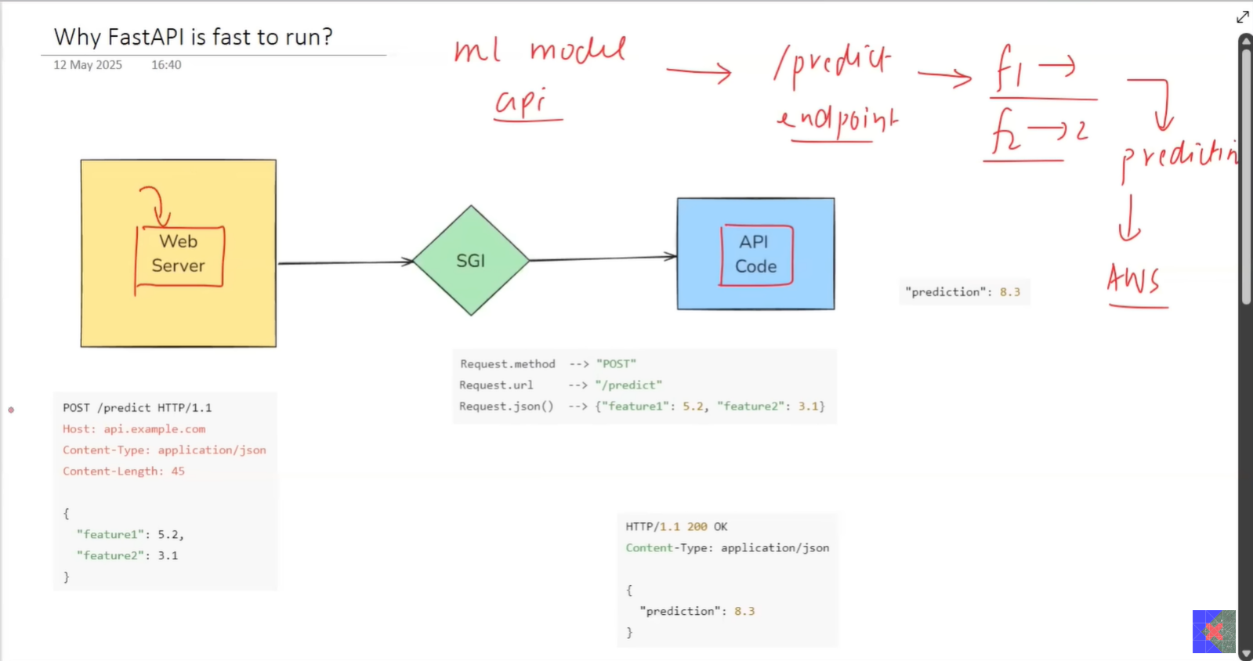

1. Flask vs FastAPI

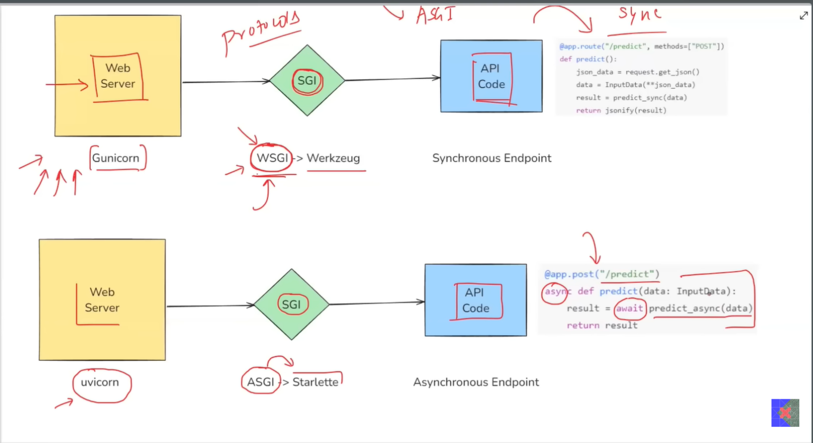

1. Why it provides easy and fast to code environment to vuild API

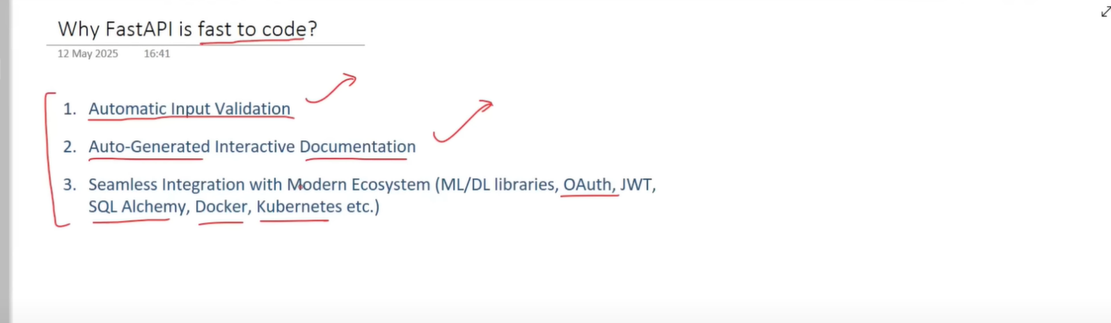

1. First API Code

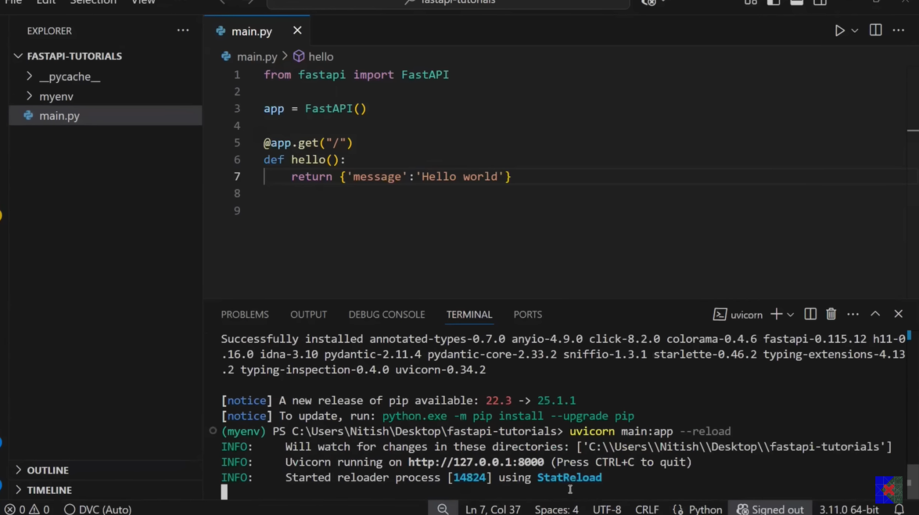

1. Successfully Created First API

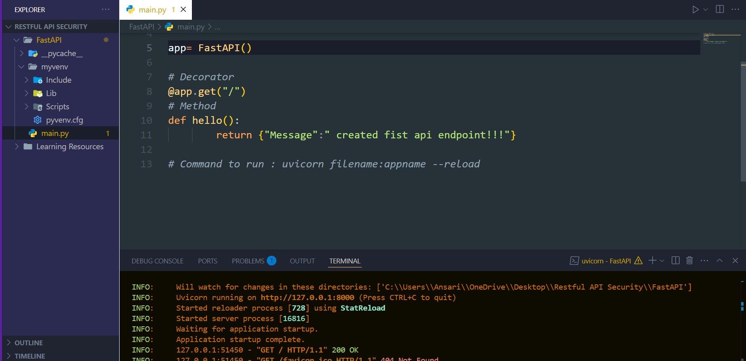

“uvicorn server is running now and and it starts listening request on http at endpoint Uvicorn running on <http://127.0.0.1:8000>

1. Project Overview

